Day 4

Tools
## Tools

Tools are an incredibly powerful feature provided by the frontier LLMs.

With tools, you can write a function, and have the LLM call that function as part of its response.

Sounds almost spooky.. we're giving it the power to run code on our machine?

Well, kinda.

- Allows frontier models to connect with external functions
  - Richer responses by extending knowledge
  - Ability to carry out actions within the application
  - Enhanced capabilities like calculations.
- What is Tool Calling?
  - 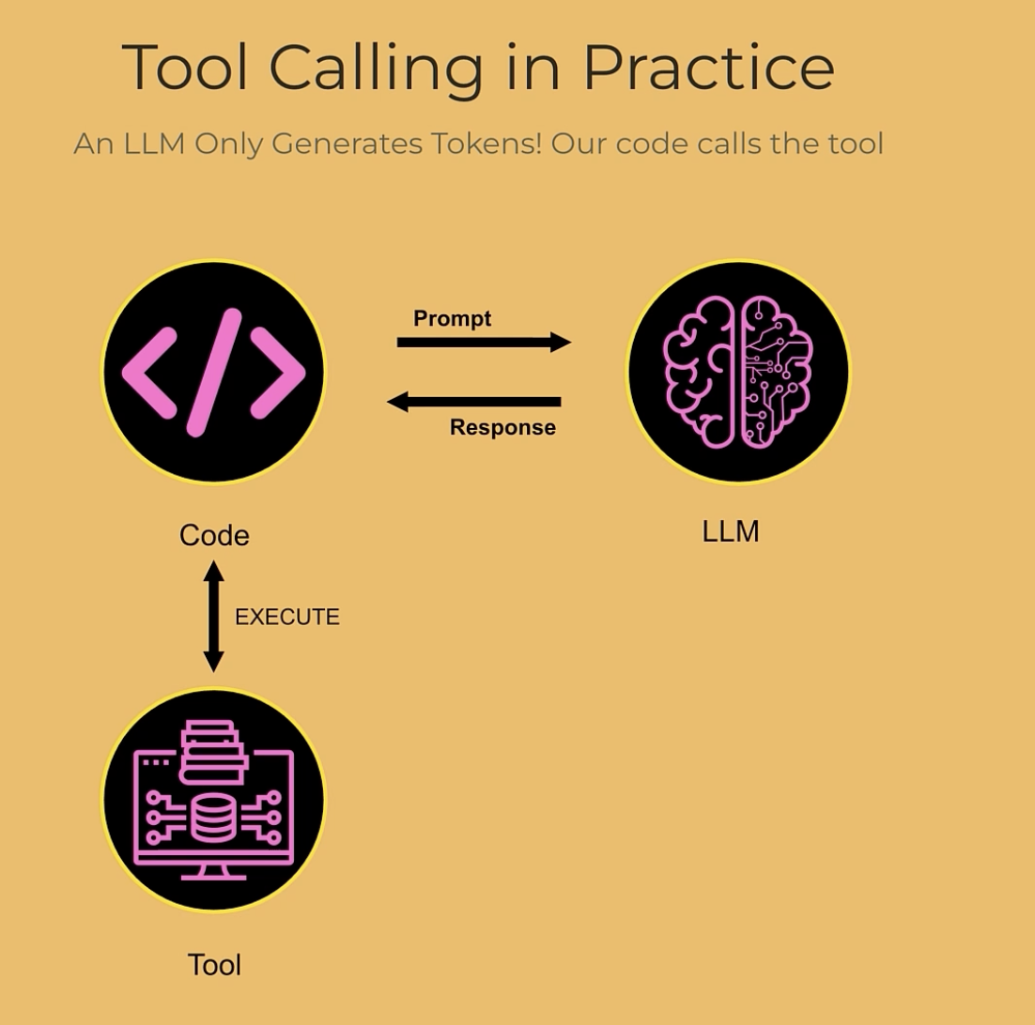
  - In practice, the code makes a call to an LLM with a prompt.
  - What comes back, LLM informs the code to run a tool to perform a particular function.
  - Then its our code that goes out and makes that python call (calling tool) and comes back with an answer .
  - Then call the LLM Second time with all the history.
  - Based on this conversation history and nothing else, cos every call is stateless, the LLM responds in a way that takes into account the calling of the tool.
  - Its just more messaging in the conversation history and that message includes a request to call the tool.
  - That is it. LLM is still just generating tokens only. It is not running the code on your computer.
  - But how would LLM to know to ask to call a particular tool?
    - In the first prompt we send to the LLM, we should let LLM know that we have the ability to run tools as and when required.
    - Example:
      - 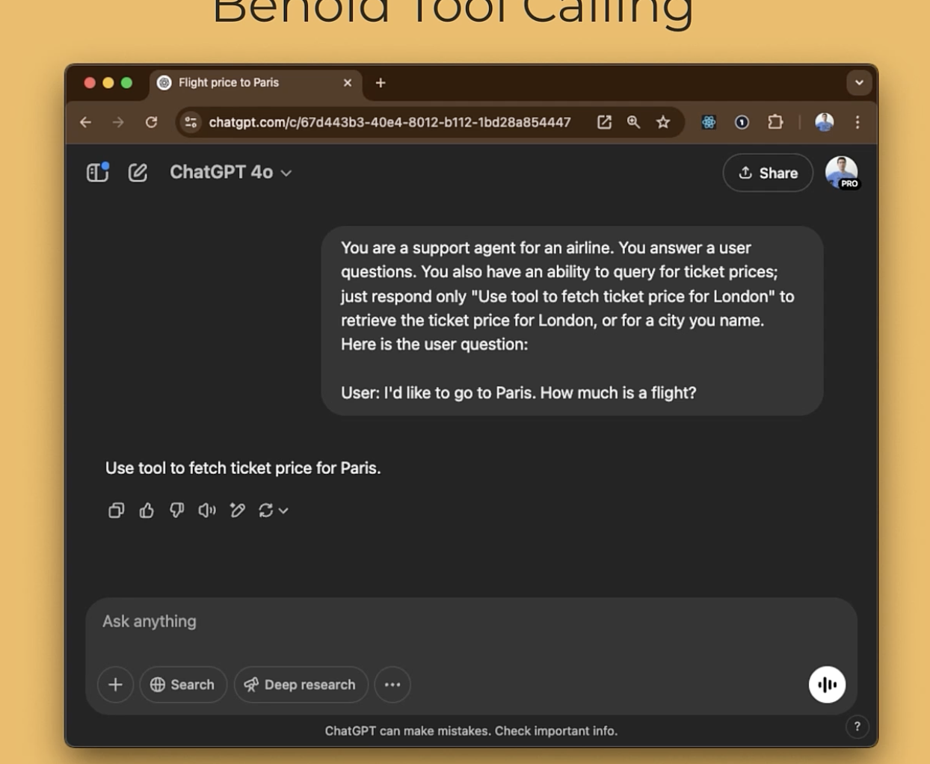

- Common use cases of Tools
  - Tools can enable assistants to :
    - Fetch data or add knowledge or context
    - Take action, like booking a meeting
    - Perform calculations or run code perhaps in a secured way like in a docker container for example – (Coder Agent – an LLM that has the ability to execute the code )
    - Modify the UI
    - Many others
  - And two other ways to use tools that form basis of agentic AI:
    - A tool can be used to make another call to an LLM
      - For example, you can say to an LLM you have 3 different tools that does task A, B and C.
      - A, B and C are actually different calls to LLMs to take care of that task
      - As a result we are equipping the LLM with an ability to orchestrate the activities of other LLM Calls and that of course is one of the core ideas behind Agentic AI, where LLM controls the workflow.
    - A tool can be used track a to do list and track progress towards a goal.
- Project – Airline Assitant
  - When we call an LLM and say you are able to use tools, we have to tell what tools it can use.
  - The way we tell it is with JSON
  - There is a fixed format.
  - For example:
    - 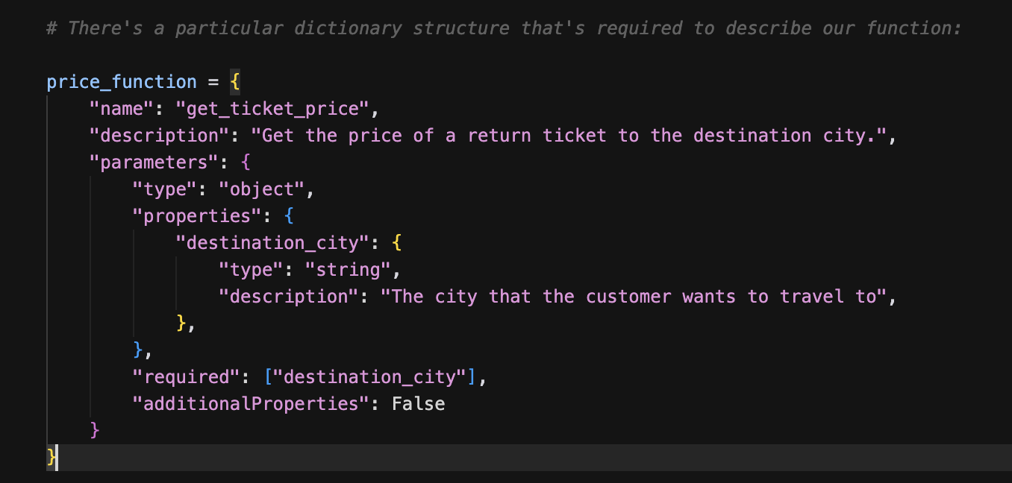

- This JSON is a way to describe the function (tool) to an LLM so that the LLM knows that it can call on our behalf if you wish it to.
- 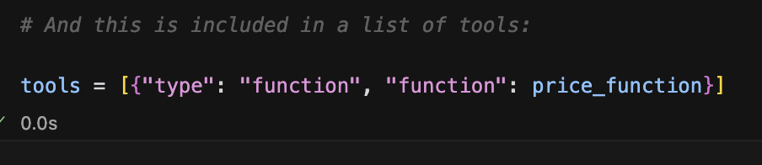
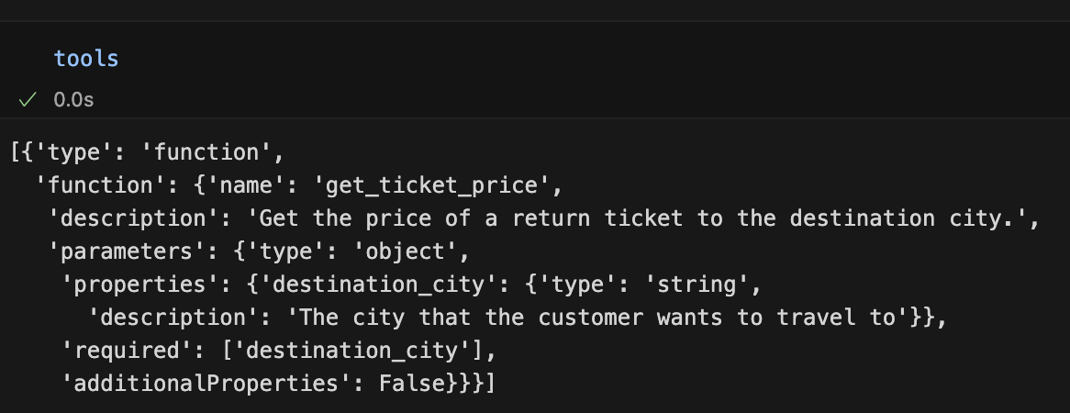
And this is what we are going to be sending into an LLM

- Now let’s call the LLM
  - When we first call the LLM, we need to pass in these tools, these JSON.
  - When LLM responds to us, we are gonna have to detect if LLM is asking to run the tool. If yes, we should run the tool, get a response and then send that response as a new message with the whole conversation history back to LLM.
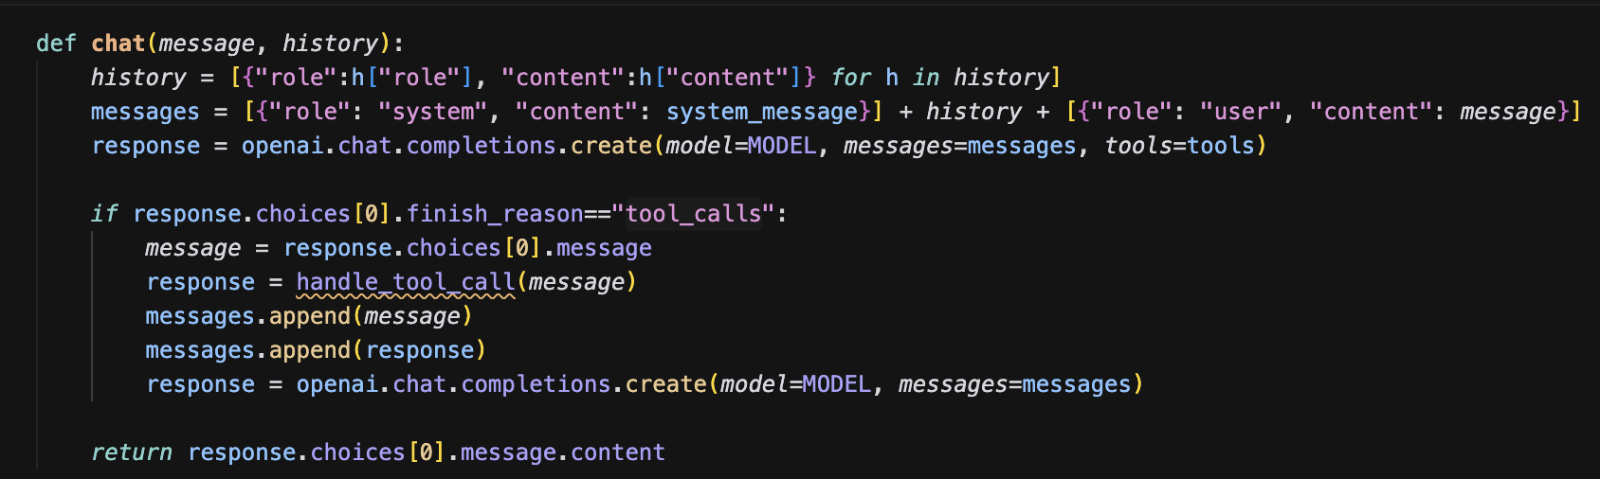
In the first response above, we are sending tools (that JSON) to the LLM.In the last line above, we are calling LLM a second time, passing in the longest set of messages, which includes message asking tool to be called and the reply with that tool information. Finally we will return the final response.

What is this “handletoolcall(message)” ?
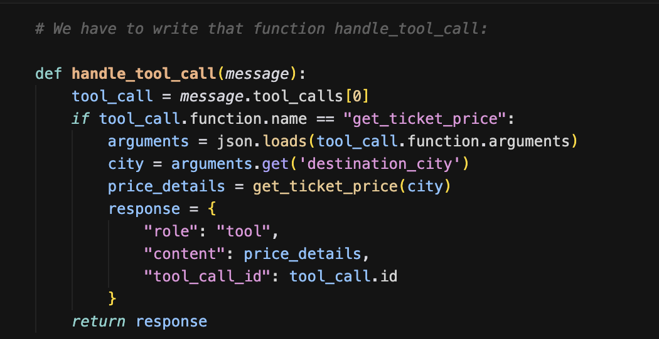
This will look at the function name from tool call. If it is “get ticket price”, it loads the json and calls the function that was defined earlier (get_ticket_price) to get the price details. Response will contain a new role – tool.
So in summary, we make these 2 different calls to GPT, first one is hey I want you to call a tool, and the second one is where we pass back all the information including the results of running the tool and that is what GPT will intelligently interpret it and responds at the end.
Now lets look at why this happened?
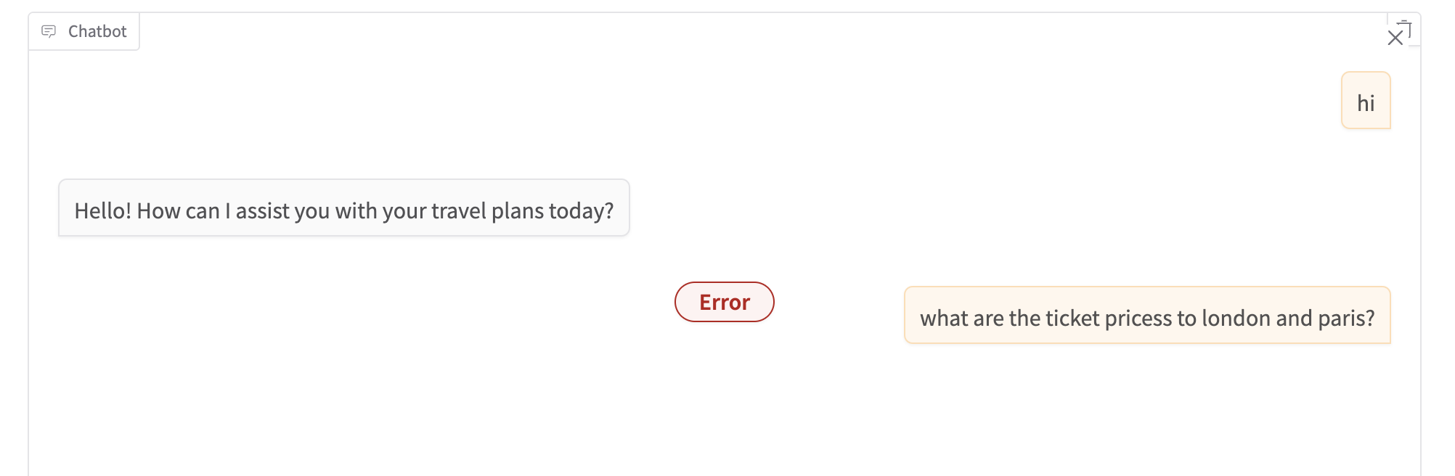

This is because our code just looks at the first tool calling. Doesn’t allow LLM to run multiple tools. This is in the “handle_tool_call” function.
This is the new function. It doesn’t just take the first tool, but ratherit iterates for tools calls in message.tool_calls
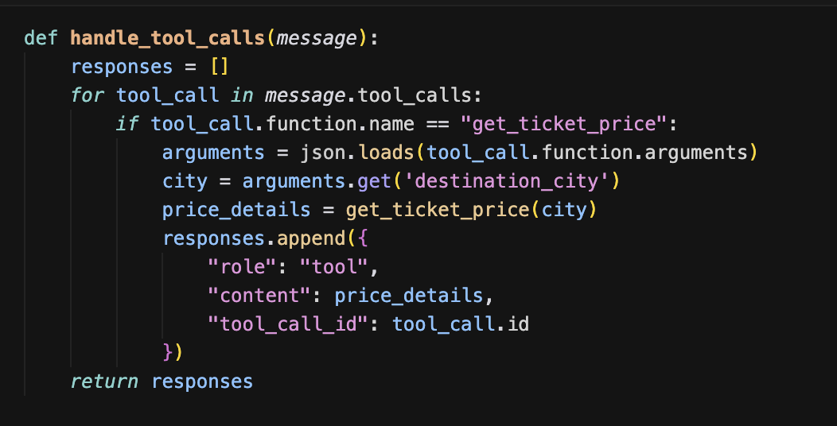
So if LLM asks to run multiple tools, we simply iterate thru each one.
See below. It worked now.
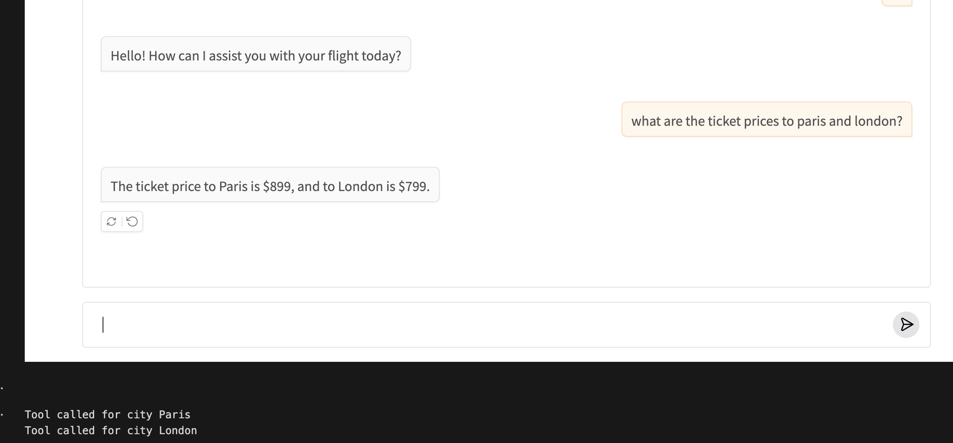

There is another gap here. See below:
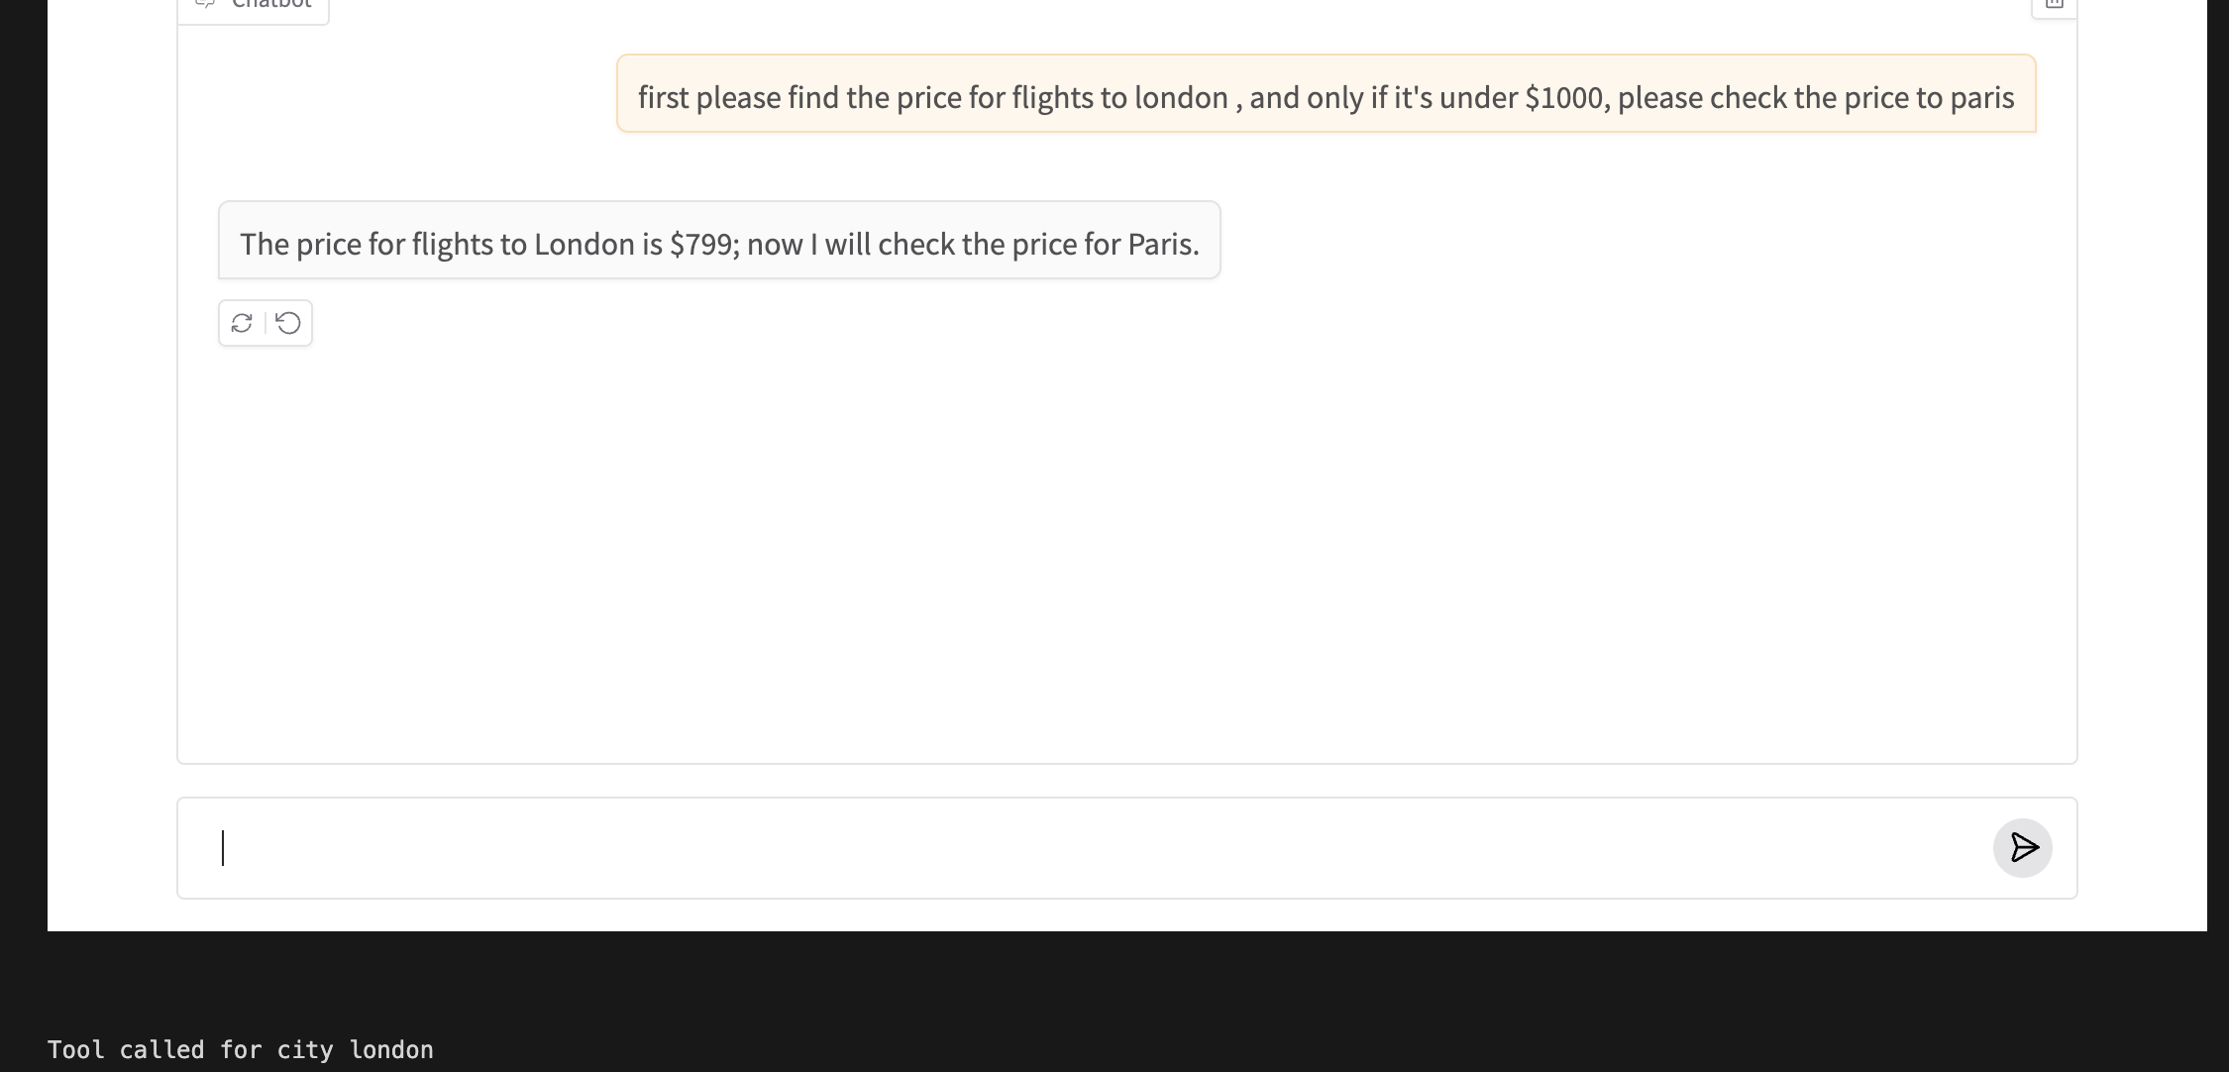
Because our code doesn’t support LLM making more than one set of tool calls sequentially.In any response, it can say I want to call multiple tools, but it cant respond and then I call it again and then it says now I want to call another tool.This isn’t supported.
This can be achieved by a slight modification to the chat function. – change if to a while function.
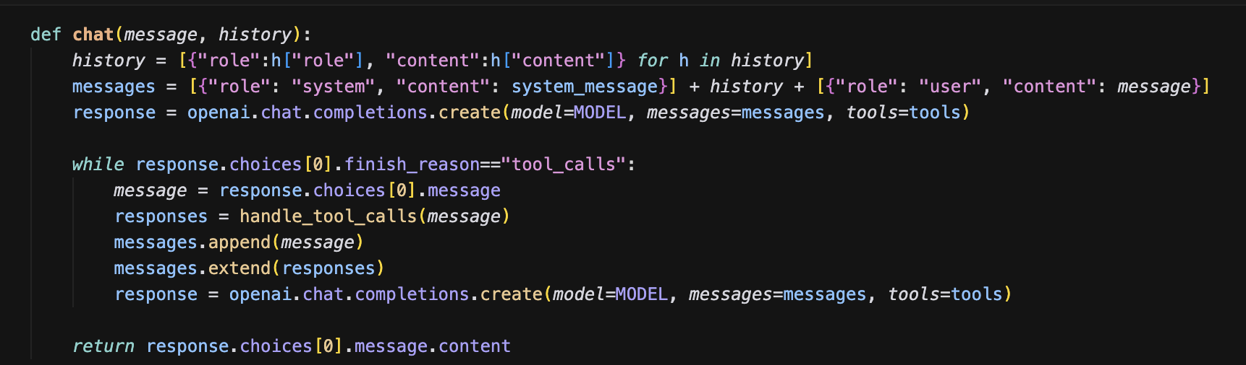
Two changes – replace if with while. Provide tools in second call to LLM.
Its fixed now:
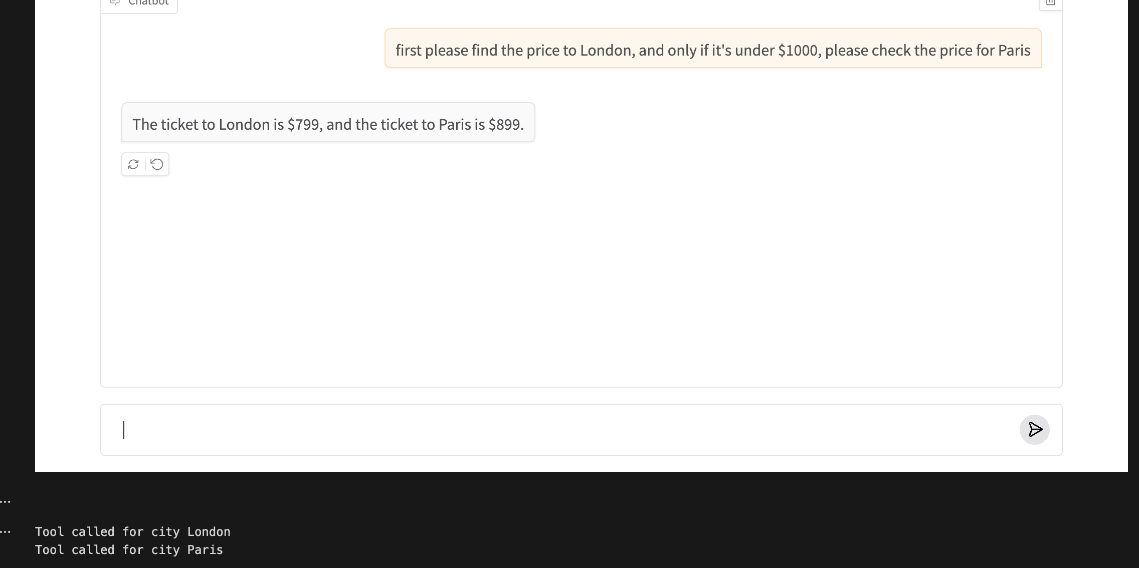

So now we have improved tool calling so that it can call multiple tools at a time and it can repeatedly call tools until the finish_reason <> tool_calls.

Instead of having to look at prices in a Python dictionary, let’s use a database
We will use sqlite, part of the uv project. With this new implementation of get_ticket_price (calling a DB vs dictionary), let’s look at the chat interface.
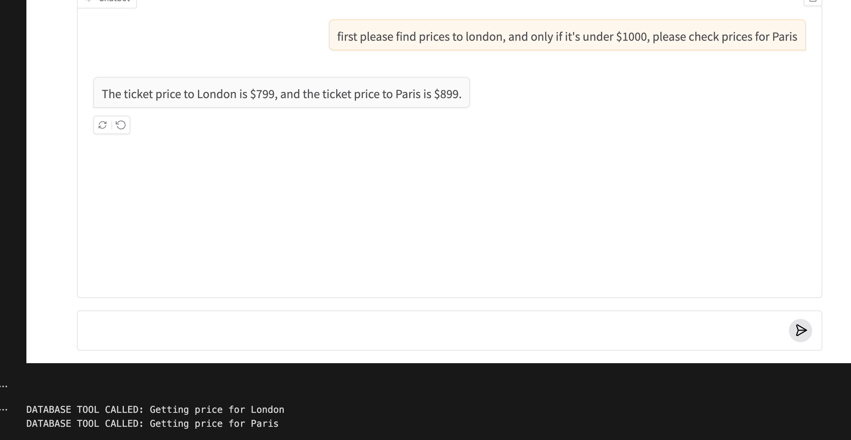
For a robust commercial application, all the history , tool calling etc must be staged in the database. Gradio just uses the history that’s shown on the UI.
We can also stream back results. Its little difficult for streaming when you are also tool calling.

